Crystal Reports

Info: <https://github.com/rainforestnet/CrystalReportsNinja>

Beginner tutorial: https://www.youtube.com/watch?v=mzVk4taNgdg

VTC Beginner tutorial: <https://www.youtube.com/watch?v=AlwEIL-oc2U&list=PLMDfT0LnMFdO4os9TNheyqituFXLjjozw>

File location: normally in d:/cafm/afmdata/crystal_auto

Crystal Reports 10 Setup – search for the txt file in the zip, should have info

What Crystal Can Do

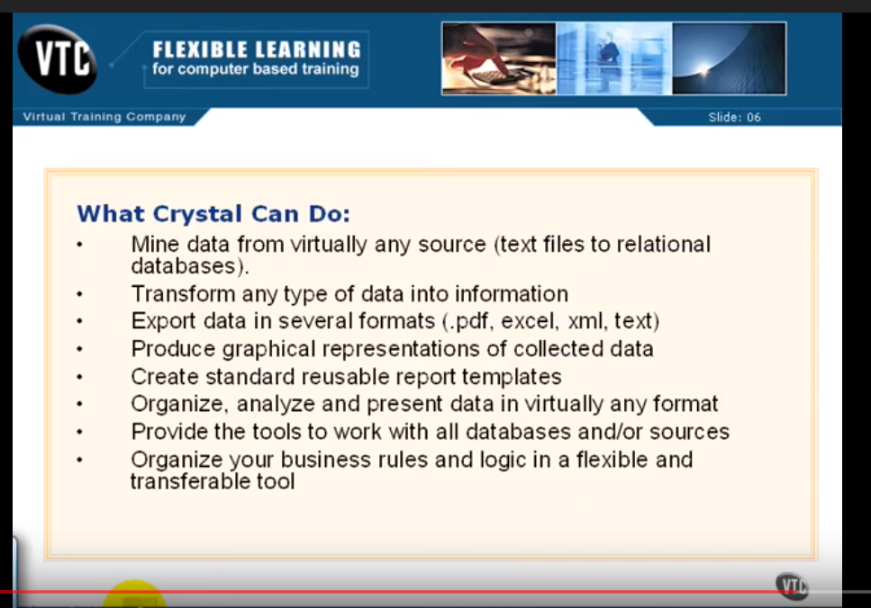

What Crystal CANNOT Do

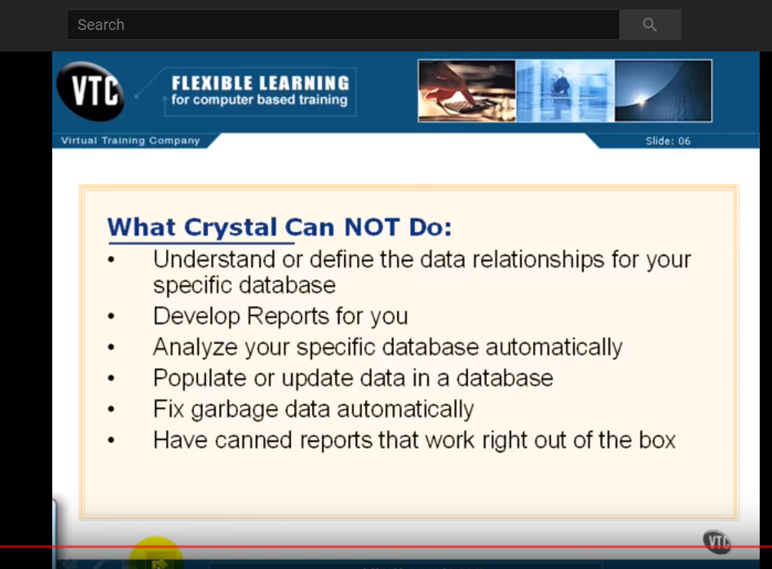

(If you close Design or Preview, bring them back with ctrl+d, ctrl+p)

**Create New Report – always use ODBC, do not use ACCESS/EXCEL**

File, new

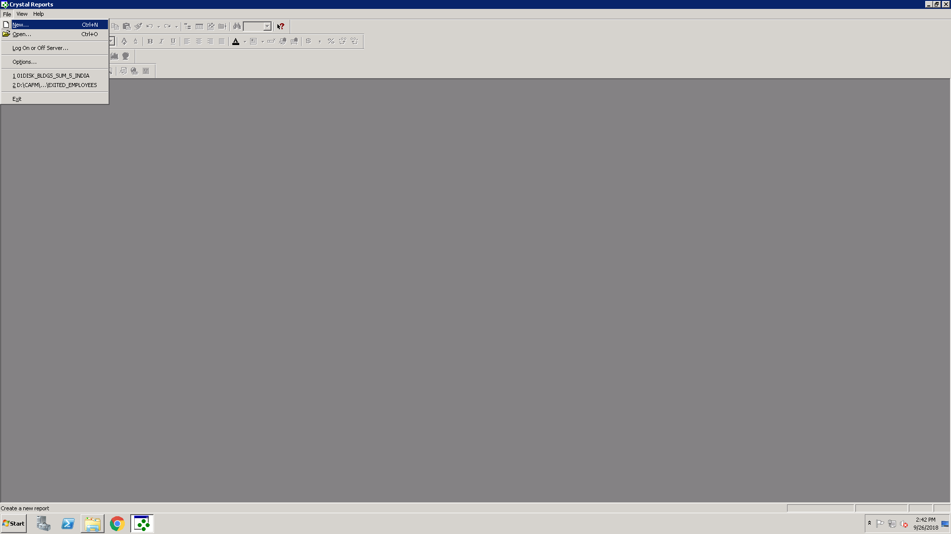

Choose standard, ok

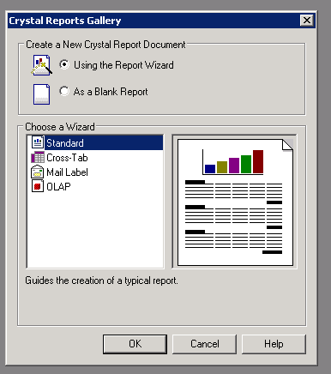

Choose a connection or make a new one

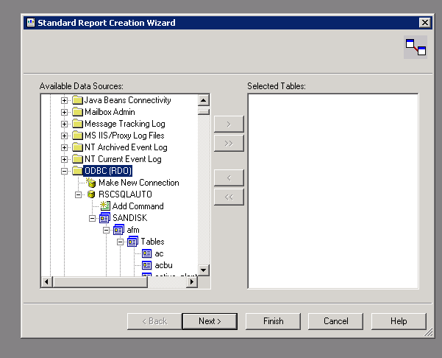

Making a new connection

Choose ODBC, RSCSQLAUTO, username and password afm

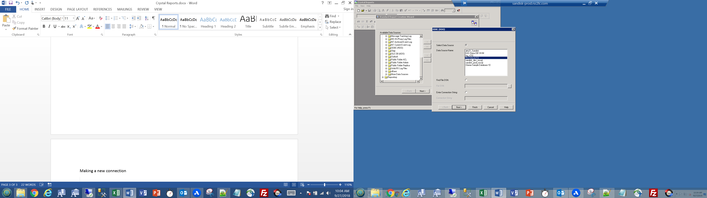

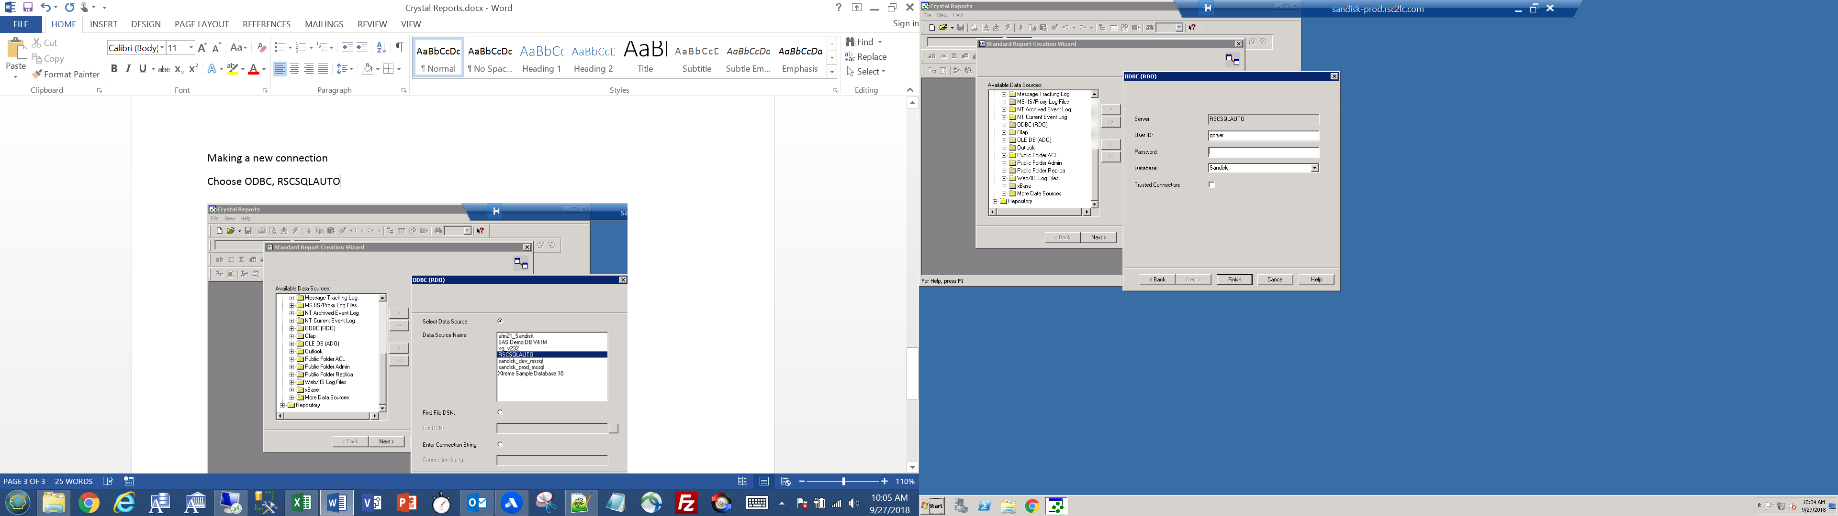

Select tables, fields to use in the Crystal Report

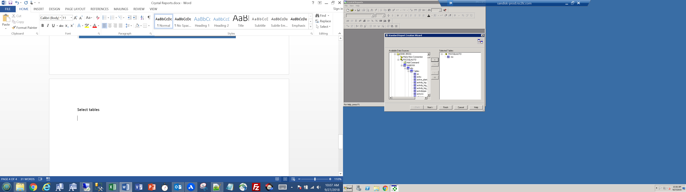

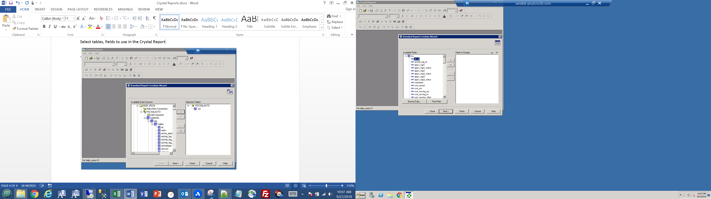

Use Select Expert to filter fields

Report -> Select Expert

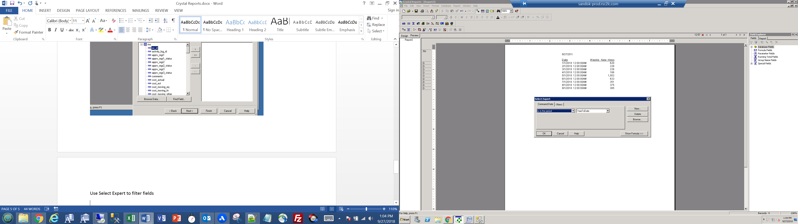

Format a field

Right click on the field in design view details portion, select Format Field… and the Format Editor appears

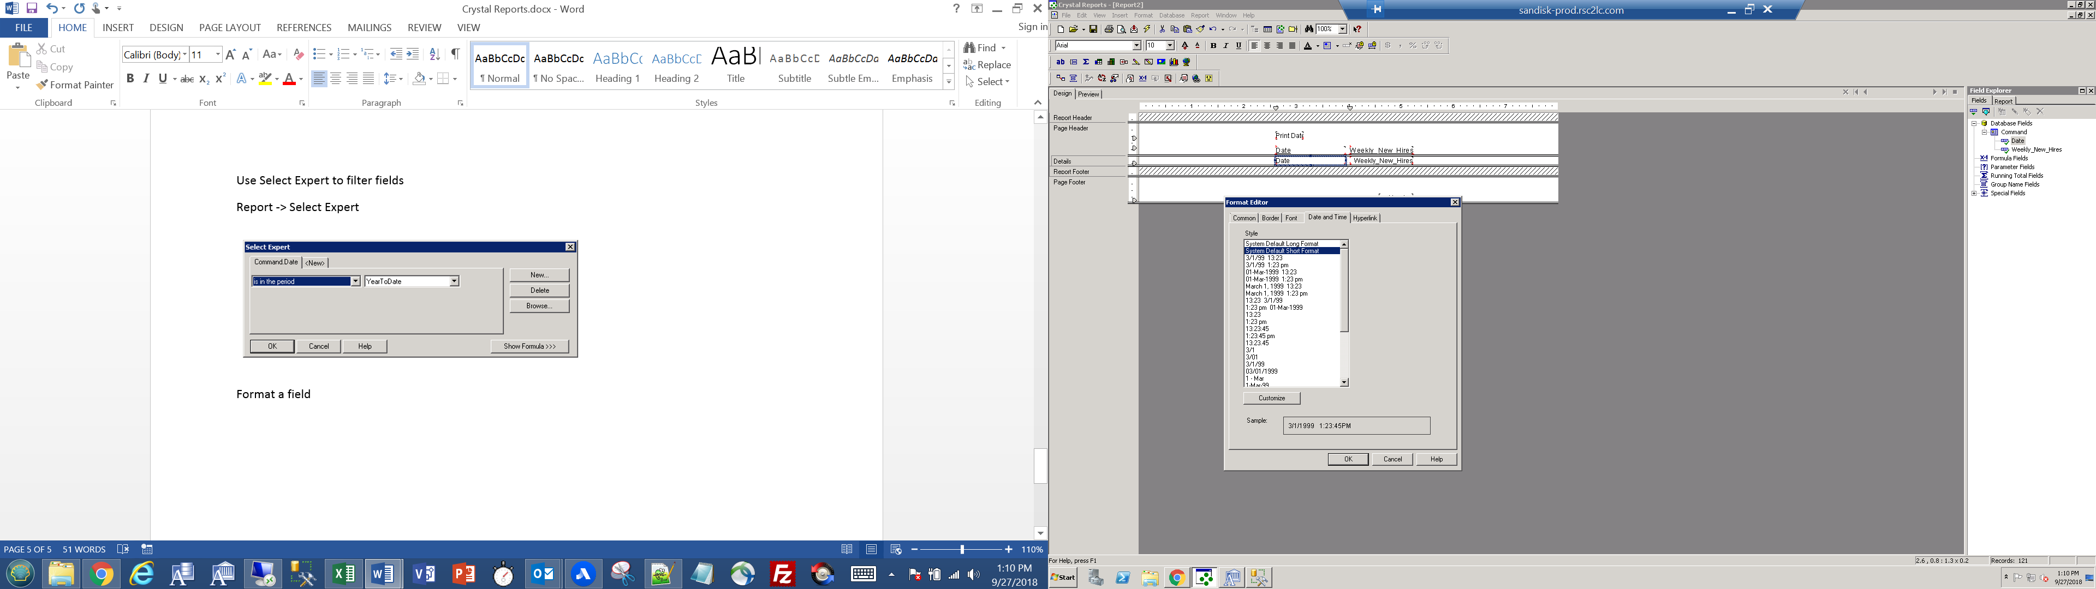

Add SQL Query

When creating a report, select Add Command above the tables, Paste query, hit ok

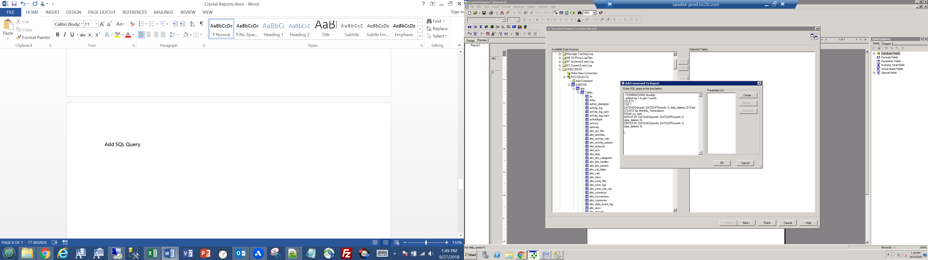

Move the fields over to “Fields to Display”, hit next twice then finish

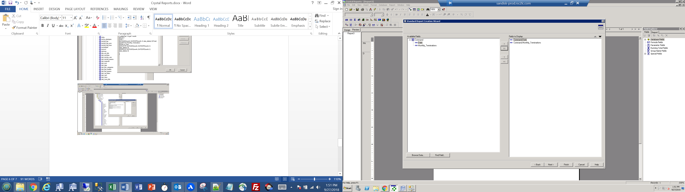

Edit an existing Sql Query

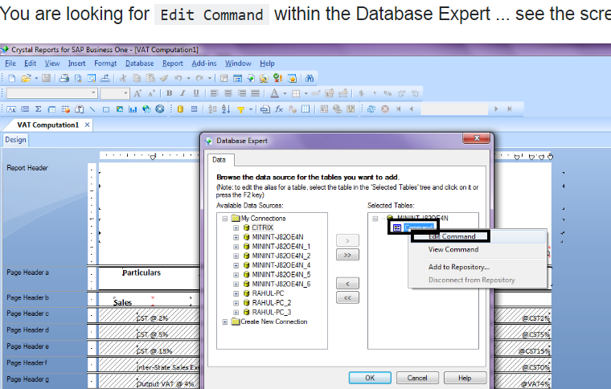

Running a report

Hitting the refresh button will make you re enter DB credentials and we re run the report/query

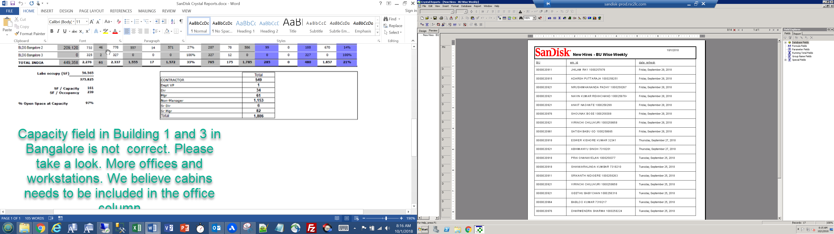

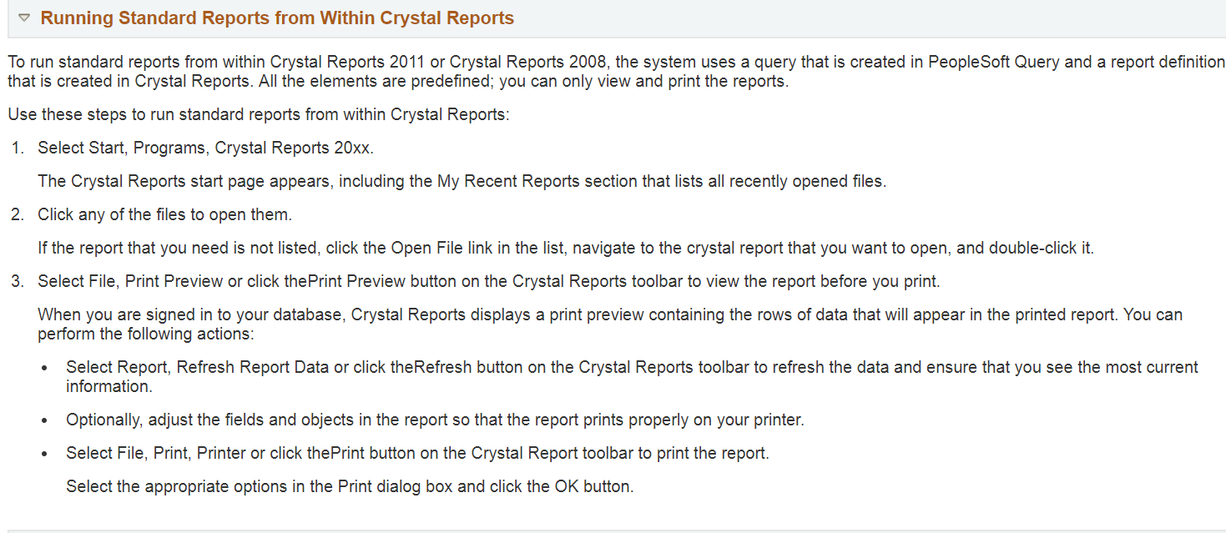

Show Next Page – top right of preview window

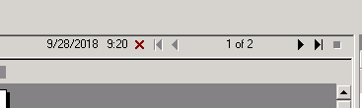

Test for NULL, @ about 5:30 in this video

<https://www.youtube.com/watch?v=eNyuiFXPj8M>

In formula editor IF ISNULL({Command.date_completed}) = TRUE THEN "BLANK"

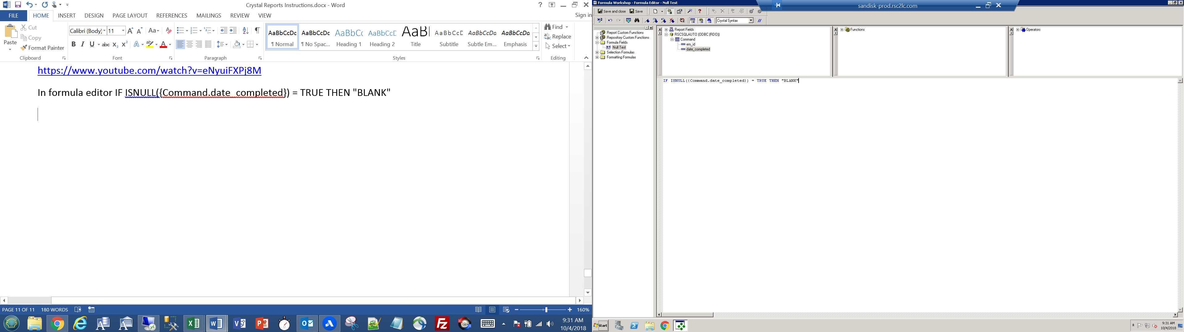

Section Expert explanation @ 2:00

<https://www.youtube.com/watch?v=239l_zpnYp8>

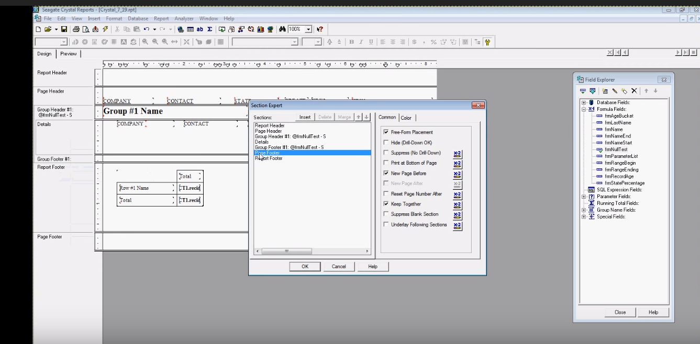

Embedding 1 formula in another @ 12:00

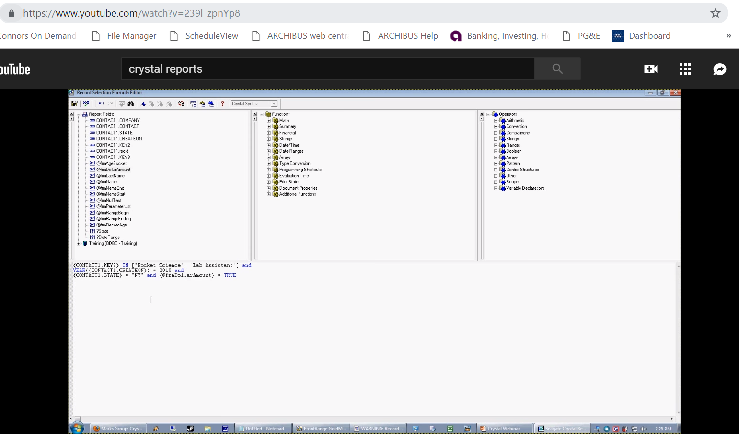

Parameter Fields

<https://www.youtube.com/watch?v=B3RJ1xOZ7hk>

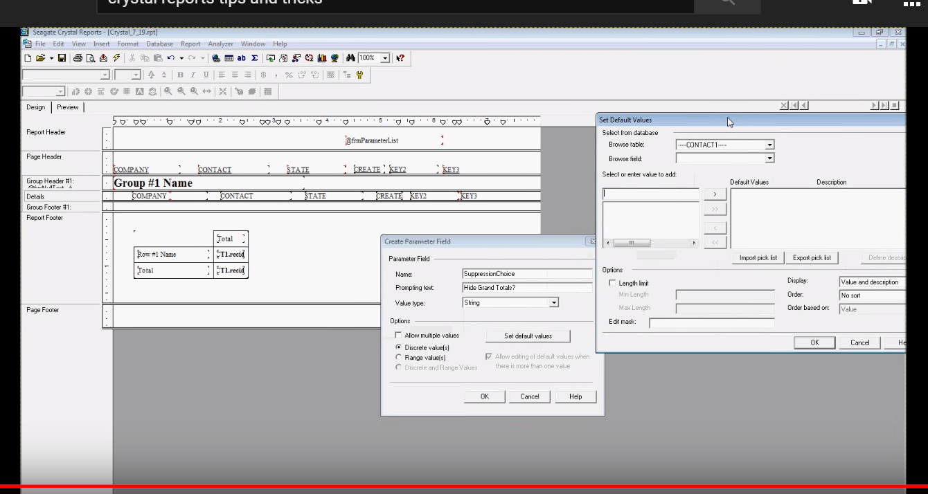

Formatting Percentages – around 11:40

<https://www.youtube.com/watch?v=PMcrcDsB88U>

Subtracting Totals And Fields– drag and drop formula fields you made

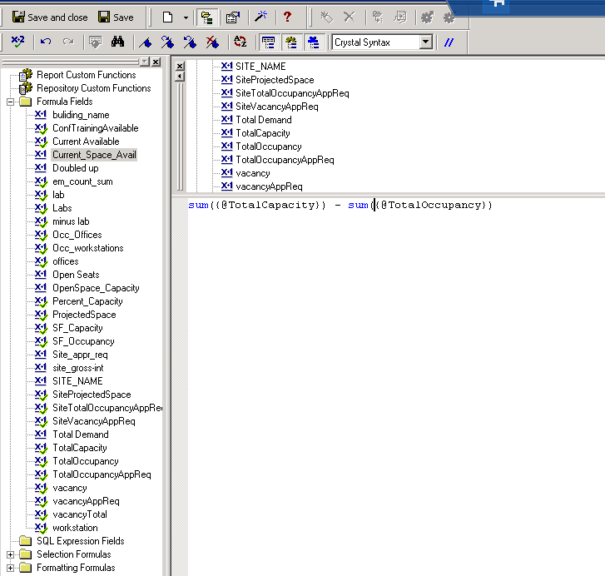

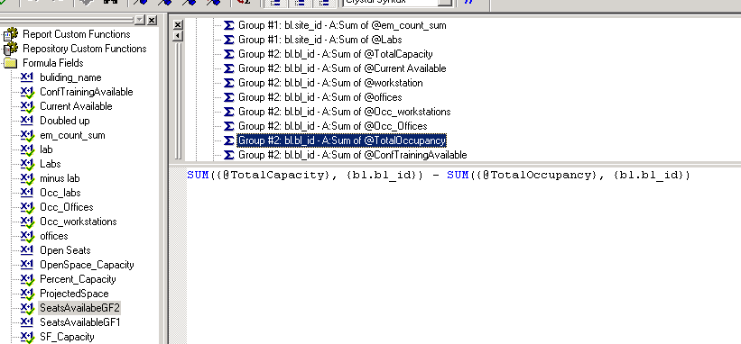

Cross Tab

Below is a report in web central that has been made into a Crystal Report. See the Cross-tab Expert below to see how to set up rows/columns/summarized fields

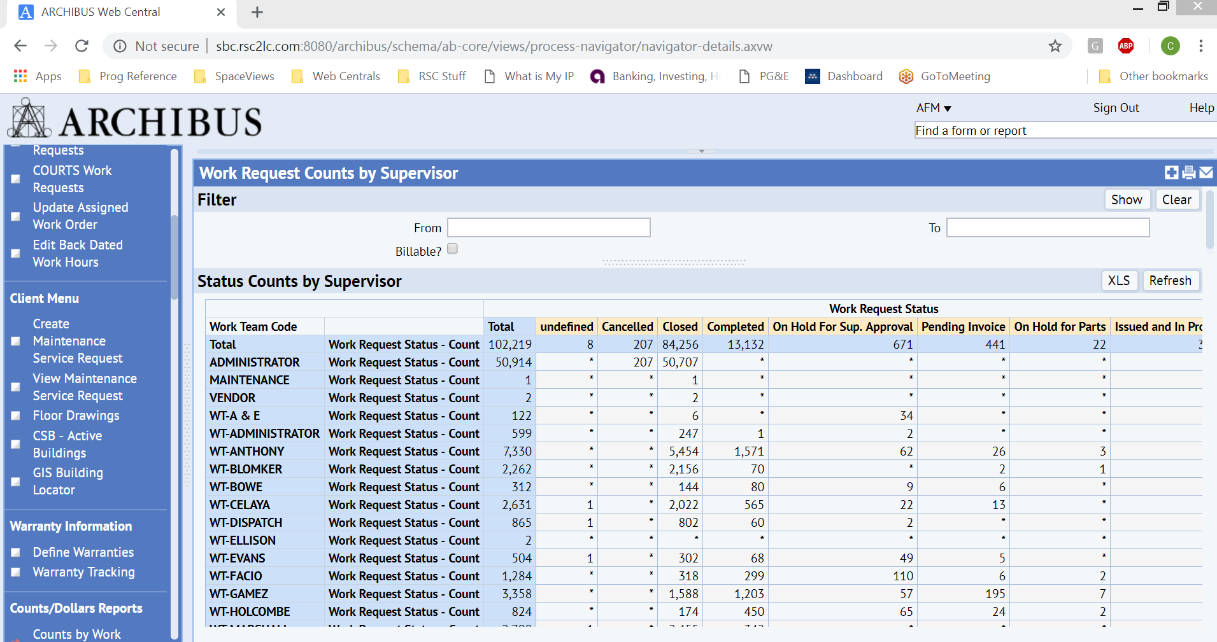

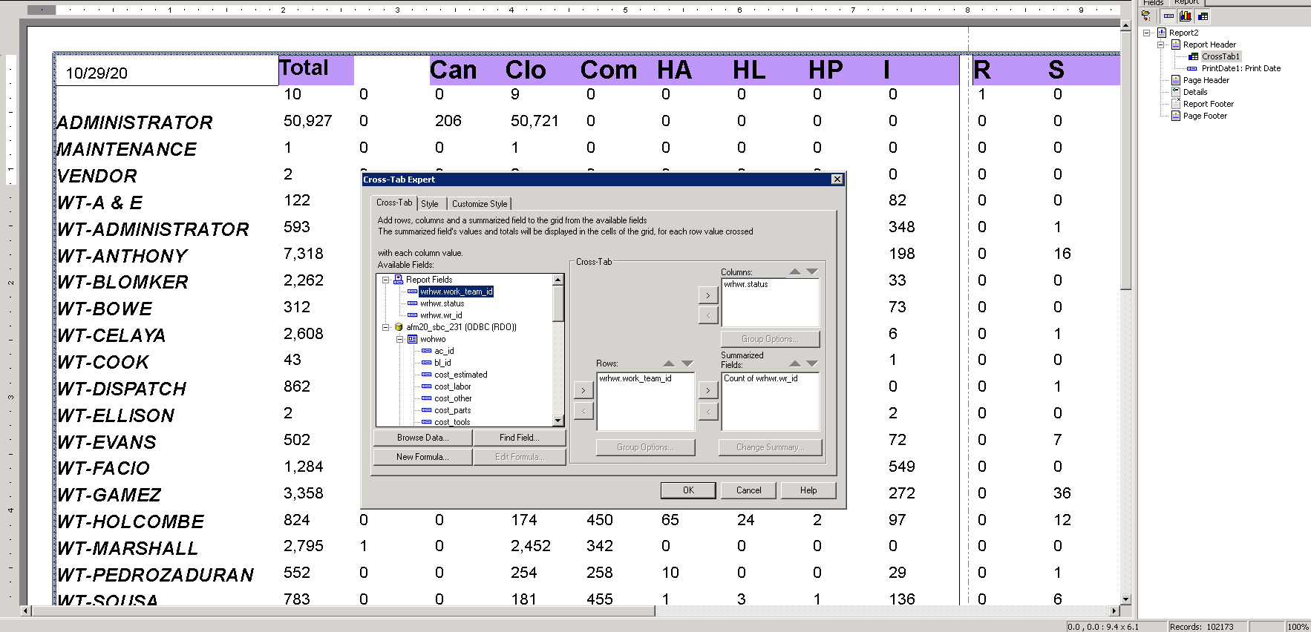

**Alias Column names**

Use Group Options in the expert, use a formula as a group name, and mimic the following

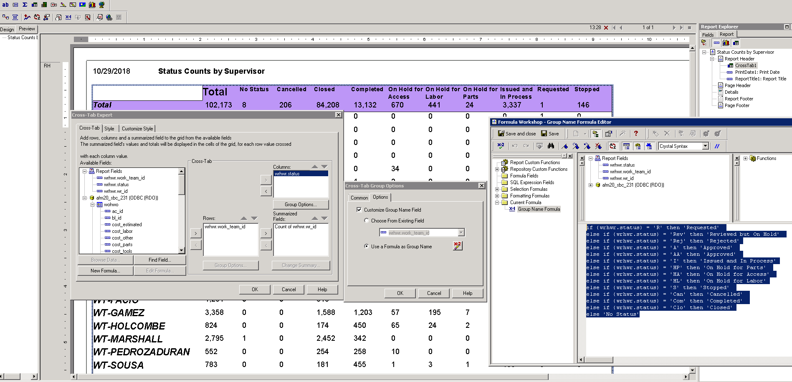

if {wrhwr.status} = 'R' then 'Requested'

else if {wrhwr.status} = 'Rev' then 'Reviewed but On Hold'

else if {wrhwr.status} = 'Rej' then 'Rejected'

else if {wrhwr.status} = 'A' then 'Approved'

else if {wrhwr.status} = 'AA' then 'Approved'

else if {wrhwr.status} = 'I' then 'Issued and In Process'

else if {wrhwr.status} = 'HP' then 'On Hold for Parts'

else if {wrhwr.status} = 'HA' then 'On Hold for Access'

else if {wrhwr.status} = 'HL' then 'On Hold for Labor'

else if {wrhwr.status} = 'S' then 'Stopped'

else if {wrhwr.status} = 'Can' then 'Cancelled'

else if {wrhwr.status} = 'Com' then 'Completed'

else if {wrhwr.status} = 'Clo' then 'Closed'

else 'No Status'

Invalid Object Name

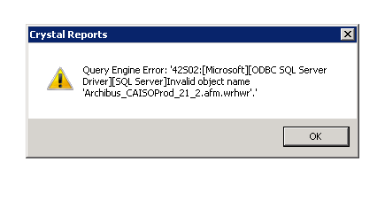

Have to update the database name. Click Database at the top of crystal, then replace the database/tables by first clicking the one in the “Current Data Source” box then finding and clicking on the replacement in “Replace with”. Hit Update on the right, and it will update the connection

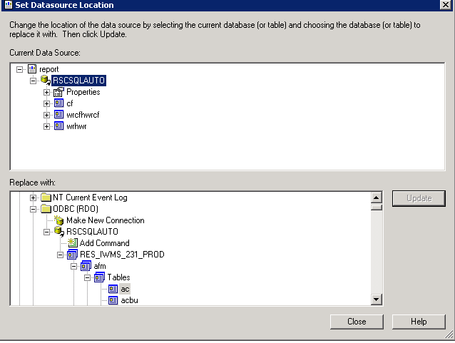

ODBC

Search for ‘odbc’ and open it

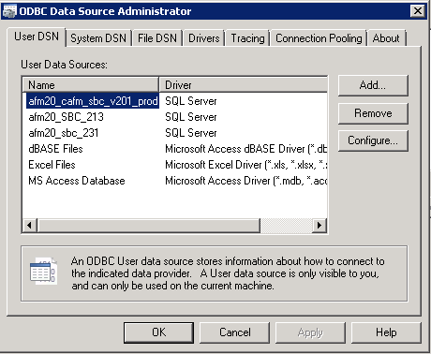

**Grouping Data:**

1. Select Insert, **Group** from the menu bar.
2. Select the field to **group** the data by from the top drop-down list.
3. Select the sort direction from the second drop-down list.

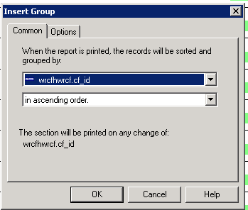

**Suppress a section**

Use section expert, select Suppress (No Drill-Down) from common section to the right <https://www.youtube.com/watch?v=ITwpBkkKlBo>

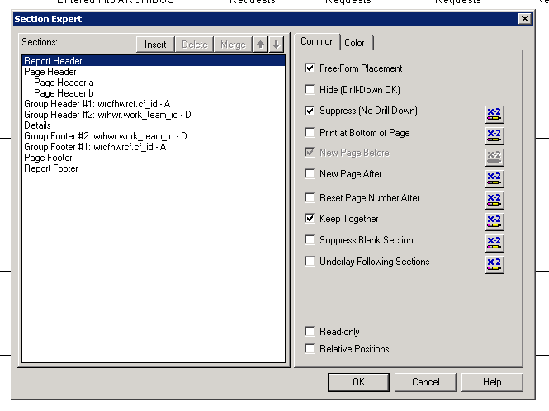

**Dates**

Shows data where date_completed is in the last 7 days or is null

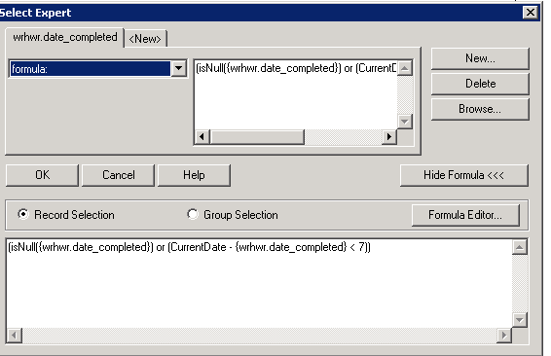

**Like condition**

Have to use ** in the formula editor

